**WEB TECHNOLOGIES (ANGULAR JS)**

PRACTICAL.NO:1

**Create an application in angular js to demonstrate arithmetic operations and list.**

**Code:**

<!DOCTYPE html>

<html lang="en">

<head>

    <meta charset="UTF-8">

    <meta name="viewport" content="width=device-width, initial-scale=1.0">

    <title>AN 01</title>

    <script src ="angular.min.js"></script>

    <style>

        *{

            margin: 0;

            padding: 0;

            box-sizing: border-box;

        }

        body {

            padding: 20px 0;

            display: flex;

            flex-direction: column;

            align-items: center;

            justify-content: center;

            gap: 10px;

        }

        div {

            width: 700px;

            display: flex;

            flex-direction: column;

            padding: 20px;

            background-color: aqua;

        }

    </style>

</head>

<body ng-app="">

    <div>

        <h1>This is my First page </h1>

        <br> Amount = {{5+9}} <br> division = {{100/5}}

    </div>

    <div ng-init="marks = [50,80,100,50,70]">

        <h1>This is my Second page </h1>

        Subject 1 = {{marks [0]}} <br>

        Subject 2 = {{marks [1]}} <br>

        Subject 3 = {{marks [2]}} <br>

        Subject 4 = {{marks [3]}} <br>

        Subject 5 = {{marks [4]}} <br>

    </div>

    <div ng-init="people=2; reg=20">

        <h1>This is my Third page </h1>

        Amount is {{people*reg}}

    </div>

</body>

</html>

**Output: -**

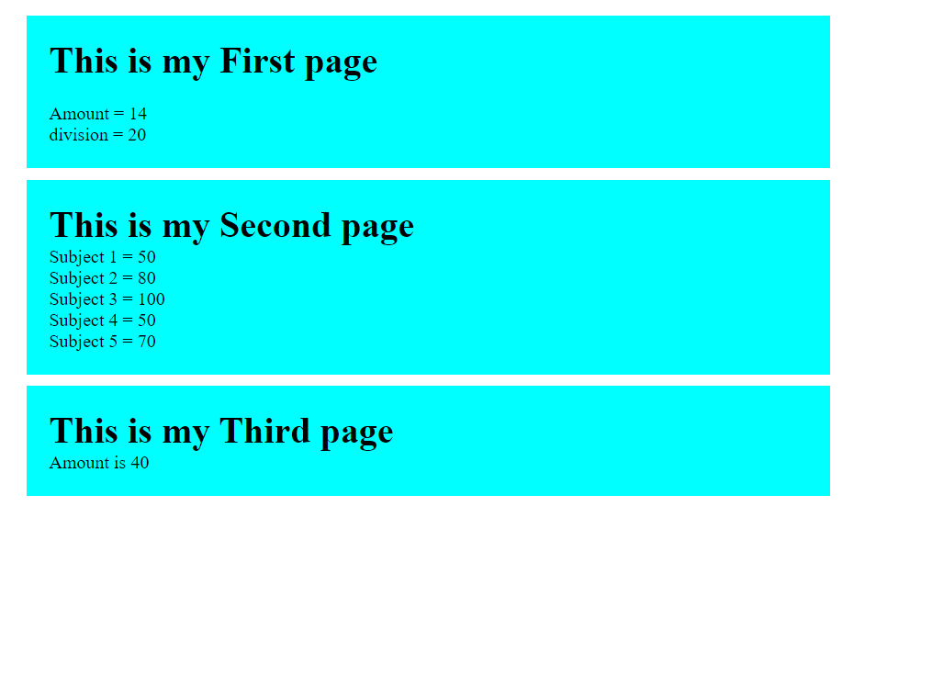

PRACTICAL.NO:2

**Create an application in angular js to calculate registration fees if the number of people and registration amount is given by the user**

**Code:**

<!DOCTYPE html>

<html lang="en">

<head>

    <meta charset="UTF-8">

    <meta name="viewport" content="width=device-width, initial-scale=1.0">

    <title>AN 02</title>

    <style>

        *{

            margin: 0;

            padding: 0;

            box-sizing: border-box;

        }

        body {

            padding: 20px 0;

            display: flex;

            flex-direction: column;

            align-items: center;

            justify-content: center;

            gap: 10px;

        }

        div {

            width: 700px;

            display: flex;

            flex-direction: column;

            padding: 20px;

            background-color: aqua;

        }

        input {

            padding: 10px 20px;

        }

    </style>

    <script src="angular.min.js"></script>

</head>

<body ng-app>

    <div>

        <h1>Calculate </h1>

        Enter the number of People <input type="number" ng-model="pop">

        Enter the reg fess <input type="number" ng-model="rege">

        Charges = {{pop*rege}}

    </div>

</body>

</html>

**Output: -**

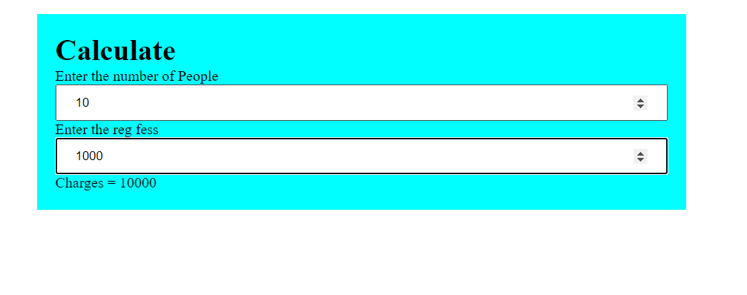

PRACTICAL.NO:3

**Create an application in angular js to calculate simple interest take appropriate input from the user**

**Code:**

<!DOCTYPE html>

<html lang="en">

<head>

<meta charset="UTF-8">

<meta name="viewport" content="width=device-width, initial-scale=1.0">

<title>AN 03</title>

<style>

*{

margin: 0;

padding: 0;

box-sizing: border-box;

}

body {

padding: 20px 0;

display: flex;

flex-direction: column;

align-items: center;

justify-content: center;

gap: 10px;

}

div {

width: 700px;

display: flex;

flex-direction: column;

padding: 20px;

background-color: aqua;

}

input {

padding: 5px 20px;

}

</style>

<script src="angular.min.js"></script>

</head>

<body ng-app>

<div>

<h1>Calculate </h1>

<span>Principle = <input type="number" ng-model="prin"></span>

<span>Rate of Interest = <input type="number" ng-model="roi"></span>

<span>Time (in Years) = <input type="number" ng-model="t"></span>

<span>Simple Inrest is = {{(prin*roi*t)/100}} </span>

</div>

</body>

</html>

**Output: -**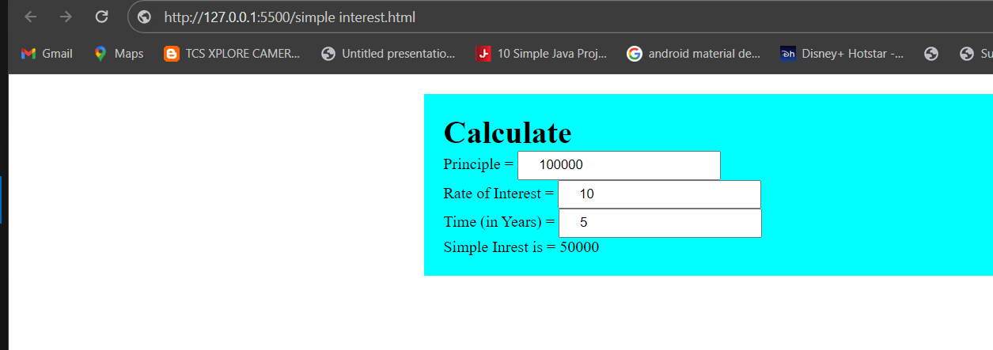

PRACTICAL.NO:4

**Write an application in angular js to create an array of names and display all the names which has letter “i” using controller**

**Code:**

**<!DOCTYPE html>**

**<html lang="en">**

**<head>**

**<meta charset="UTF-8">**

**<meta name="viewport" content="width=device-width, initial-scale=1.0">**

**<title>Document</title>**

**<script src="./angular.min.js"></script>**

**</head>**

**<body>**

**<div ng-app="myApp" ng-controller="namesCtrl">**

**<ul>**

**<li ng-repeat="x in names|filter:'i'">{{x}}</li>**

**</ul>**

**</div>**

**<script>**

**angular.module("myApp",[]).controller("namesCtrl",function($scope) {**

**$scope.names= ["omkar",**

**"carl",**

**"mink",**

**"hege",**

**"joe",**

**"gustav",**

**"birgit",**

**];**

**});**

**</script>**

**</body></html>**

**Output: -**

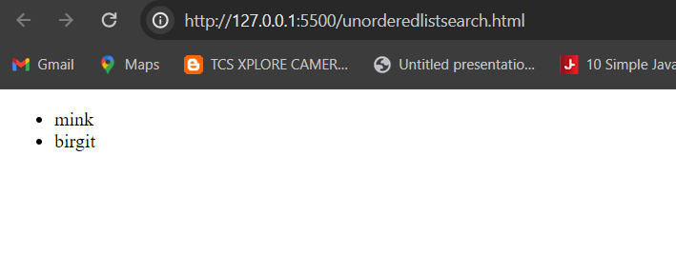

PRACTICAL.NO:5

**Create an application in angular js to demonstrate the use of filters in angular js**

**Code:**

<!DOCTYPE html>

<html lang="en">

<head>

<meta charset="UTF-8">

<meta name="viewport" content="width=device-width, initial-scale=1.0">

<title>Document</title>

<script src="./angular.min.js"></script>

</head>

<body ng-app="myApp" ngcontroller="myController">

<div>

Default currency :{{person.salary|currency}}

<br/>

customer current identification:{{person.salary}}

<br/>

No fraction:{{person.salary| currency:'Rs.':0}}

<br/>

Fraction2:<span ng-bind="person.salary|currency:'GBP':2"></span>

<br/>

</div>

<div>

<h1>Name and Number filter</h1>

FirstName:{{person.firstName|lowercase}}

<br/>

lastName:{{person.lastName|uppercase}}<br/>

NameFilter:{{person.salary|number:2}}<br>

LongDate:{{DOB|date:'LongDate'}}<br>

Year:{{DOB|date:"YYYY"}}<br/>

Monht:{{DOB|date:"MMMM"}}<br>

</div>

<div>

<h1>Limit to filter</h1>

Limit to get element from begining:{{limitarr|limitTo:3}}<br>

limit to get Element from Emding:{{limitarr|limitTo:-3}}<br>

Get element from string:{{limitarr|limitTo:4}}<br>

<script>

var myApp=angular.module('myApp',[]);

myApp.controller("myController",function($scope){

$scope.person={FirstName:'omkar',lastname:'phadke',salary:1000.657}

$scope.DOB=new Date();

$scope.limitarr=[20,30,20,34,45,56,3]

}) ; </script>

</div>

</body>

</html>

//write a program to demonstrate type of liter

**Output :-**

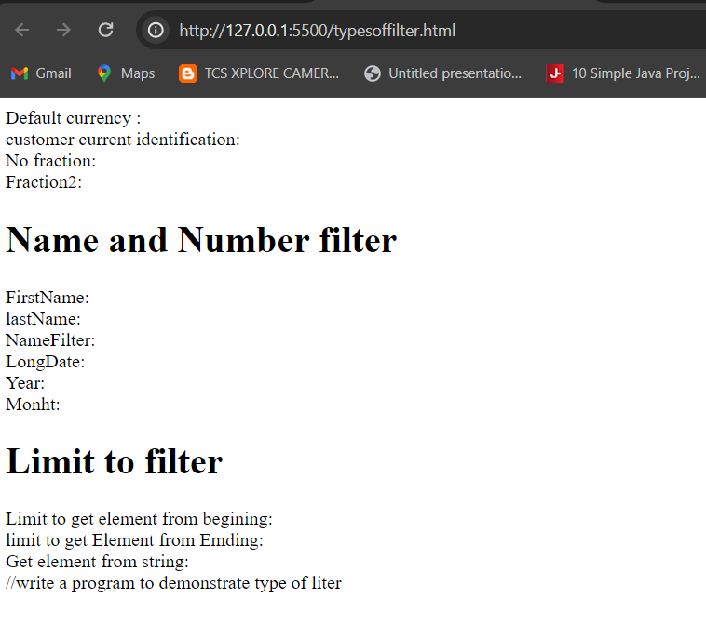

PRACTICAL.NO:6

**Create an application in angular js to change the background color as the user changes input in the text box**

**Code:**

<!DOCTYPE html>

<html lang="en">

<head>

    <title>AN 03</title>

</head>

<style>

*{

    margin: 0;

    padding: 0;

    box-sizing: border-box;

}

body{

    height: 100vh;

    display: flex;

    justify-content: center;

    align-items: center;

}

input{

    margin: 2em;

    width: 30em;

    height: 3em;

    padding: 20px;

    border: .4em solid black;

    border-radius: 20%;

    cursor: pointer;

    box-shadow: 0 0 .5em #111;

}

</style>

<body>

    <h1 class="head"> Type the color </h1>

    <! -- <input type="color" id="clr"> -->

    <input type="text" id="clr">

</body>

<script>

const bgclr = document.getElementById ("clr");

const headingg = document.querySelector(".head");

bgclr.addEventListener("input", () => {

document.body.style.backgroundColor = bgclr.value;

});

</script>

</html>

**Output :-**

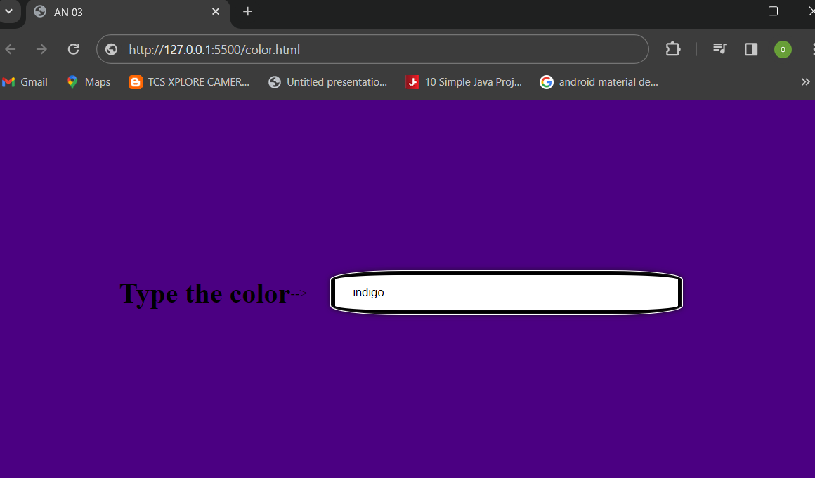

PRACTICAL.NO:7

**Create an application in angular js to demonstrate to display text in alert box**

**Code:**

<!DOCTYPE html>

<html lang="en">

<head>

    <meta charset="UTF-8">

    <meta name="viewport" content="width=device-width, initial-scale=1.0">

    <title>AN 05</title>

    <script src="angular.min.js"></script>

    <style>

        *{

            margin: 0;

            padding: 0;

            box-sizing: border-box;

        }

        body{

            display: flex;

            align-items: center;

            justify-content: center;

            height: 100vh;

        }

        button {

            padding: 10px 20px;

            background: aqua;

            border-radius: 8px;

        }

        input{

            padding: 10px 20px;

            border-radius: 8px

        }

        div{

            display: flex;

            flex-direction: column;

            width: 500px;

        }

    </style>

</head>

<body ng-app="myApp">

    <div ng-controller="myController" class="">

        Enter Password: <input type="password" ng-model="password"/> <br />

        <button ng-click="DisplayMessage(password)">Show Password</button>

    </div>

    <script>

        var myApp = angular.module("myApp", []);

        myApp.controller("myController", function ($scope, $window) {

            $scope.DisplayMessage = function (value) {

                $window.alert(value);

            }

        });

    </script>

</body>

</html>

**Output: -**

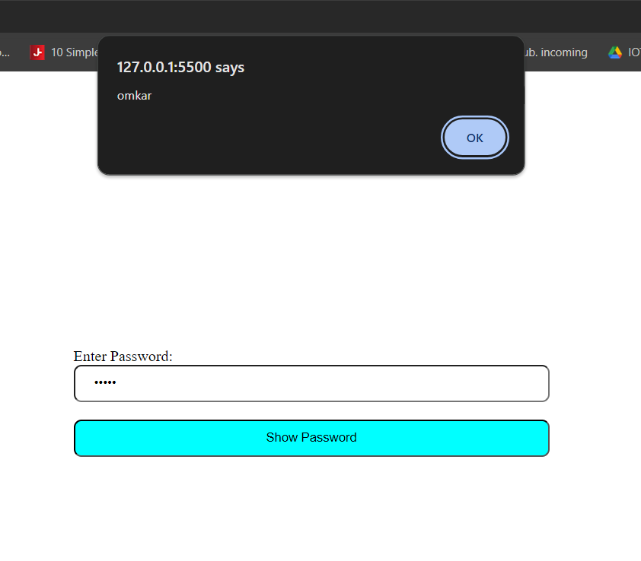

PRACTICAL.NO:8

**Create an application in angular js to demonstrate the use of ng-if, ng-disabled and ng-read only**

**Code:**

<!DOCTYPE html>

<html lang="en">

<head>

    <meta charset="UTF-8">

    <meta name="viewport" content="width=device-width, initial-scale=1.0">

    <title>AN 06</title>

    <script src="angular.min.js"></script>

    <style>

        div {

            width: 100%;

            height: 20px;

            margin: 15px 0 0 10px;

        }

    </style>

</head>

<body ng-app ng-init="checked=true">

<div>Click me:<input type="checkbox" ng-model="checked"></div>

    <div>New Textbox: <input type="text" ng-if="checked"> </div>

    <div>Read Only: <input type="text" ng-readonly="checked" value="I am read only Textbox"></div>

    <div>Disabled: <input type="text" ng-disabled="checked" value="I am Disabled"></div>

</body>

</html>

**Output :-**

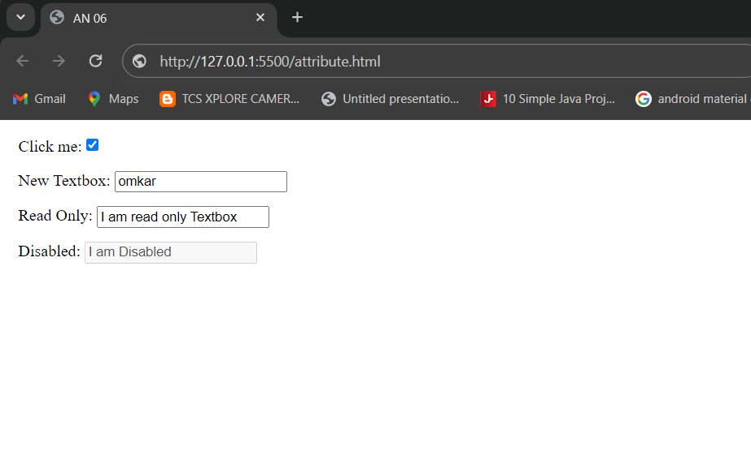

PRACTICAL.NO:9

**Create an application in angular js to demonstrate use of mouse-enter and mouse-leave event**

**Code:**

<!DOCTYPE html>

<html lang="en">

<head>

    <meta charset="UTF-8">

    <meta name="viewport" content="width=device-width, initial-scale=1.0">

    <title>AN 07</title>

    <script src="angular.min.js"></script>

    <style>

        .redDiv {

            width: 100px;

            height: 100px;

            background-color: red;

            padding: 20px;

        }

        .yellowDiv {

            width: 100px;

            height: 100px;

            background-color: yellow;

            padding: 20px

        }

    </style>

</head>

<body ng-app>

    <div ng-class="{redDiv:enter,yellowDiv:leave}" ng-mouseenter="enter=true;leave=false"

        ng-mouseleave="enter=false;leave=true”  >

        Mouse

        <span ng-show="enter">Enter</span>

        <span ng-show="leave">Leave</span>

    </div>

</body>

</html>

**Output :-**

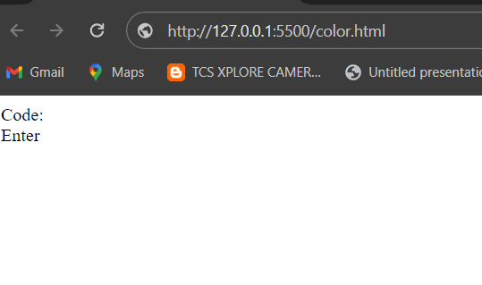

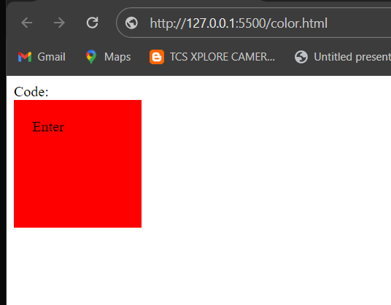

PRACTICAL.NO:10

**Write an application in angular js to display options using select tag as user chooses the color option the respective color and content should change**

**Code:**

<!DOCTYPE html>

<html lang="en">

<head>

    <meta charset="UTF-8">

    <meta name="viewport" content="width=device-width, initial-scale=1.0">

    <title>AN 08</title>

    <script src="angular.min.js"></script>

</head>

<body ng-app="">

<div><form>

    Select Color:

    <select ng-model="myVar">

        <option value="pink">Pink</option>

        <option value="blue">Sky Blue</option>

        <option value="lav">Lavender</option>

    </select>

</form>

</div>

<div ng-switch="myVar">

    <div ng-switch-when=""></div>

</div>

<div ng-switch="myVar">

<div ng-switch-when="pink" style="background-color: pink;">

<h1>Pink</h1>

<p>Pink Color</p>

</div></div>

<div ng-switch="myVar">

<div ng-switch-when="blue" style="background-color: lightblue;">

<h1>Sky Blue</h1>

<p>Sky Blue Color</p>

</div></div>

<div ng-switch="myVar">

<div ng-switch-when="lav" style="background-color: rgb(226, 184, 253);">

<h1>Lavender</h1>

<p>Lavender Color</p>

</div></div>

<p>The ng-switch directive hides and shows the HtML sections depending on the value of the dropdown list </p>

</body>

</html>

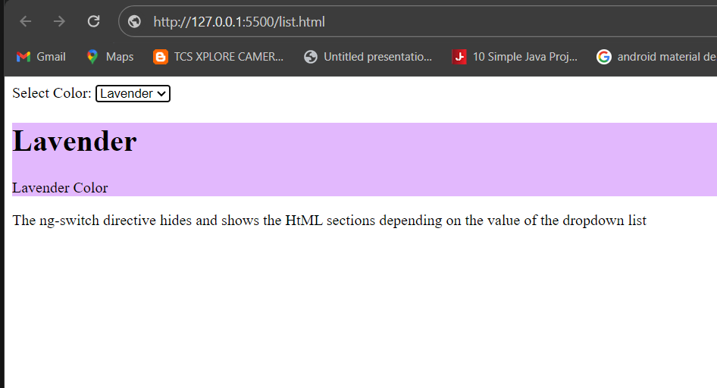**Output: -**

PRACTICAL.NO:11

**Write an angular js code to display a registration form for student applying for a new course. Display all the values entered by the students.**

**Code:**

<!DOCTYPE html>

<html lang="en">

<head>

<meta charset="UTF-8">

<meta name="viewport" content="width=device-width, initial-scale=1.0">

<title>Document</title>

</head>

<body ng-controller="studentController">

<h1>Student Information:</h1>

<form ng-submit="submitStudnetForm()">

<label for="firstName">First Name: </label><br />

<input type="text" id="firstName" ng-model="student.firstName" /> <br />

<label for="lastName">Last Name</label><br />

<input type="text" id="lastName" ng-model="student.lastName" /> <br />

<label for="dob">DoB</label><br />

<input type="date" id="dob" ng-model="student.DoB" /> <br /><br />

<label for="gender">Gender</label> <br />

<select id="gender" ng-model="student.gender">

<option value="male">Male</option>

<option value="female">Female</option>

</select><br /> <br />

<span>Training Type:</span><br />

<label><input value="online" type="radio" name="training" ng-model="student.trainingType" />Online</label><br />

<label><input value="onsite" type="radio" name="training" ng-model="student.trainingType" />OnSite</label>

<br /><br />

<span>Subjects</span><br />

<label><input type="checkbox" ng-model="student.maths" />Maths</label> <br />

<label><input type="checkbox" ng-model="student.physics" />Physics</label> <br />

<label><input type="checkbox" ng-model="student.chemistry" />Chemistry</label><br /><br />

<input type="submit" value="Submit" ng-click="msg()" />

<input type="reset" ng-click="resetForm()" value="Reset" />

</form>

<script>

//1. create app module

var studentApp = angular.module('studentApp', []);

//2. create controller

studentApp.controller("studentController", function ($scope, $http, $window) {

//3. attach originalStudent model object

$scope.originalStudent = {

firstName: 'James',

lastName: 'Bond',

DoB: new Date('01/31/1980'),

gender: 'male',

trainingType: 'online',

maths: false,

physics: true,

chemistry: true

};

//4. copy originalStudent to student. student will be bind to a form

$scope.student = angular.copy($scope.originalStudent);

//5. create submitStudentForm() function. This will be called when user submits the form

$scope.submitStudnetForm = function () {

var onSuccess = function (data, status, headers, config) {

alert('Student saved successfully.');

};

var onError = function (data, status, headers, config) {

alert('Error occured.');

}

$http.post('/student/submitData', { student: $scope.student })

.success(onSuccess)

.error(onError);

};

//6. create resetForm() function. This will be called on Reset button click.

$scope.resetForm = function () {

$scope.student = angular.copy($scope.OriginalStudent);

};

$scope.msg = function () {

$window.alert("ho gaya karke");

}

});

</script>

</body>

</html>

**Output :**

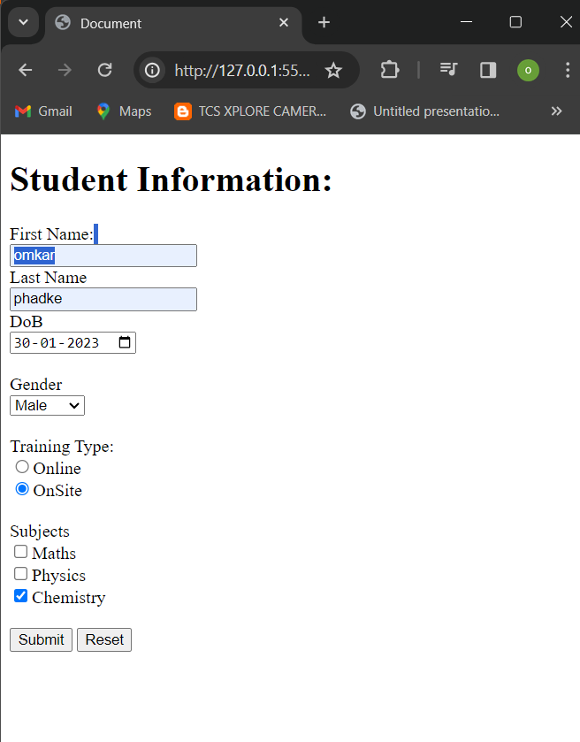

PRACTICAL.NO: 12

**To demonstrate the use of regular expressions for validating input fields in a form**

**Code:**

<!DOCTYPE html>

<html lang="en">

<head>

<meta charset="UTF-8">

<meta name="viewport" content="width=device-width, initial-scale=1.0">

<script src='angular.min.js'></script>

<title>Document</title>

</head>

<body ng-app="app" style="text-align:center">

<h1 style="color:green;">Regular Expression for input field</h1>

<div ng-controller="reg">

<ng-form name="num">

Input Number:

<input type="text" ng-model="number" name="number" ng-pattern="re" /><br />

<span ng-show="num.number.$error.pattern" style="color:red">

Input is not valid.

</span>

</ng-form>

</div>

</body>

<script>

var app = angular.module("app", []);

app.controller('reg', ['$scope', function ($scope) {

$scope.re = /^[0-9]{1,6}$/;

}]);

</script>

</html>

**Output:** -

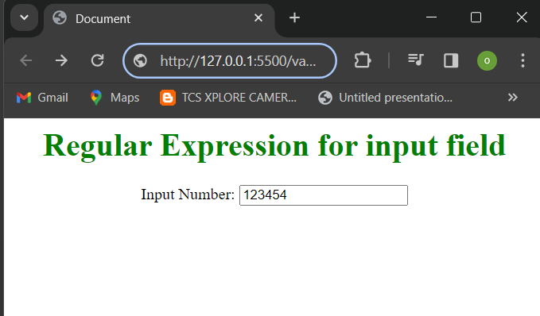

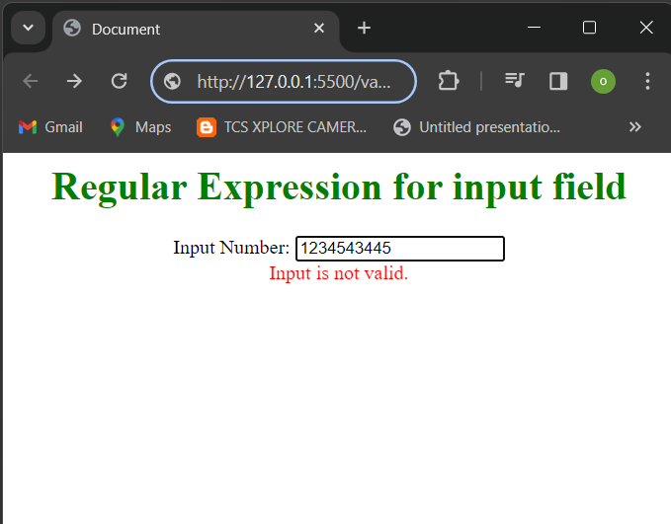

PRACTICAL.NO:13

**To demonstrate use of validation directives**

**Code:**

<!DOCTYPE html>

<html lang="en">

<head>

<meta charset="UTF-8">

<meta name="viewport" content="width=device-width, initial-scale=1.0">

<title>Document</title>

<script src='angular.min.js'></script>

</head>

<body ng-app>

<form name="studentForm" novalidate>

<label for="firstName">First Name: </label> <br />

<input type="text" name="firstName" ng-model="student.firstName" ng-required="true" />

<span ng-show="studentForm.firstName.$touched &&

studentForm.firstName.$error.required">First name is required.</span><br /><br />

<label for="lastName">Last Name</label><br />

<input type="text" name="lastName" ng-minlength="3" ng-maxlength="10" ng-model="student.lastName" />

<span ng-show="studentForm.lastName.$touched &&

studentForm.lastName.$error.minlength">min 3 chars.</span>

<span ng-show="studentForm.lastName.$touched &&

studentForm.lastName.$error.maxlength">Max 10 chars.</span><br /><br />

<label for="dob">Email</label><br />

<input type="email" id="email" ng-model="student.email" name="email" />

<span ng-show="studentForm.email.$touched && studentForm.email.$error.email">Please enter

valid email id.</span><br /><br />

<input type="submit" value="Submit" />

</form>

</body>

</html>

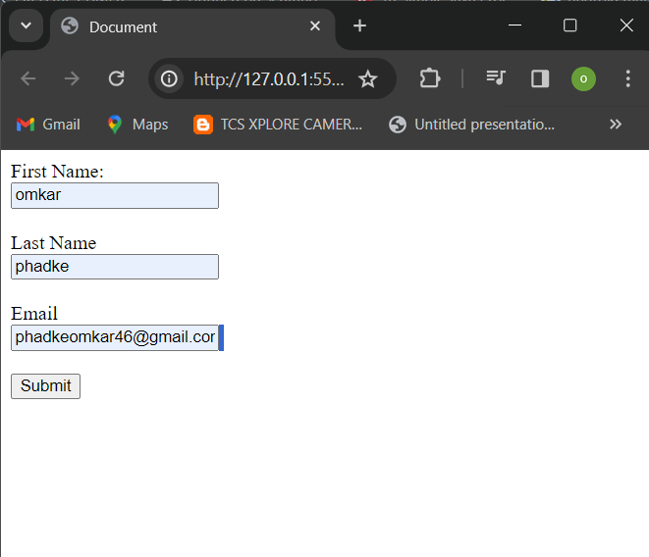**Output:**

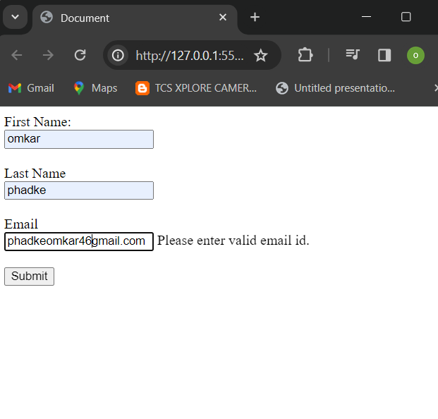

PRACTICAL.NO:14

**To demonstrate the state properties of form fields**

**Code:**

<!DOCTYPE html>

<html lang="en">

<head>

<meta charset="UTF-8">

<meta name="viewport" content="width=device-width, initial-scale=1.0">

<title>Document</title>

<script src='angular.min.js'></script>

</head>

<body ng-app>

<form name="studentForm" novalidate>

<p>

First Name Status: <br />

Pristine: {{studentForm.firstName.$pristine}} <br />

Touched: {{studentForm.firstName.$touched}}<br />

Untouched: {{studentForm.firstName.$untouched}}<br />

Valid: {{studentForm.firstName.$valid}} <br />

Invalid: {{studentForm.firstName.$invalid}} <br />

Dirty: {{studentForm.firstName.$dirty}} <br />

Error: {{studentForm.firstName.$error }} <br />

</p>

<label for="firstName">First Name: </label> <br />

<input type="text" name="firstName" ng-model="student.firstName" ng-required="true" />

<span ng-show="studentForm.firstName.$touched &&

studentForm.firstName.$error.required">First name is required.</span><br /><br />

<label for="lastName">Last Name</label><br />

<input type="text" name="lastName" ng-minlength="3" ng-maxlength="10" ng-model="student.lastName" /> <br />

<span ng-show="studentForm.lastName.$error.minlength">min 3 chars.</span>

<span ng-show="studentForm.lastName.$error.maxlength">Max 10 chars.</span> <br />

<input type="submit" value="Save" />

</form>

</body>

</html>

**Output: -**

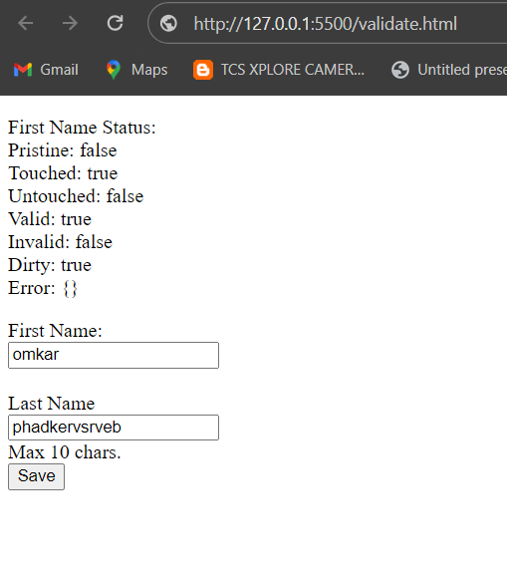

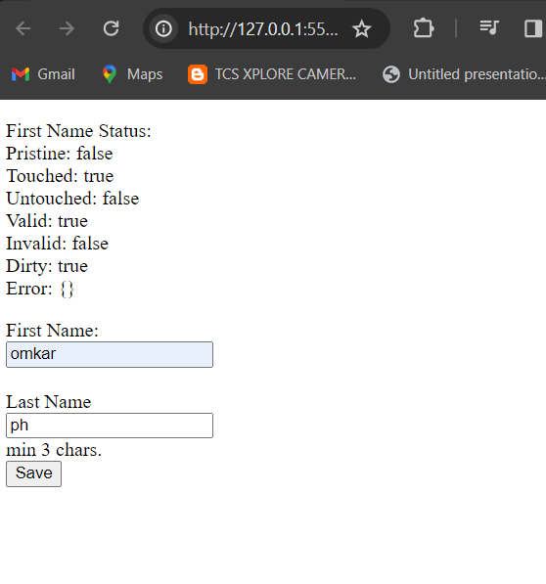

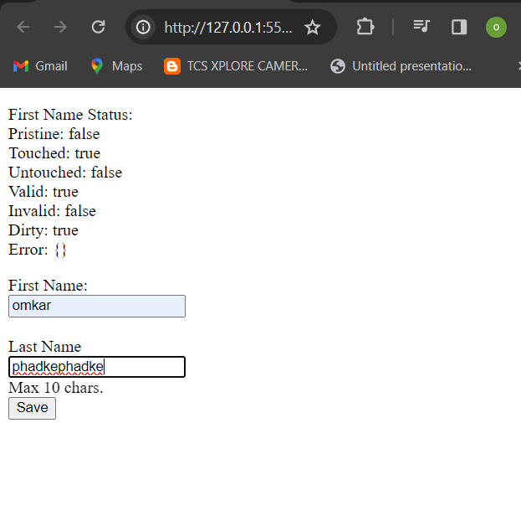

PRACTICAL.NO:15

**To demonstrate the use of a Single Page Application (SPA)**

**Code:**

<!DOCTYPE html>

<html lang="en">

<head>

<meta charset="UTF-8">

<meta name="viewport" content="width=device-width, initial-scale=1.0">

<title>Document</title>

<script src="angular.min.js"></script>

<script src="angular.route.js"></script>

</head>

<body ng-app="ngRoutingDemo">

<h1>

<center>Angular Routing Demo</center>

</h1>

<div>

<a href="#!/register">Registration</a>

<a href="#!/login">Login</a>

</div>

<div ng-view align="center"></div>

<script>

var app = angular.module('ngRoutingDemo', ['ngRoute']);

app.config(function ($routeProvider) {

$routeProvider

.when("/register", {

template: "<h2> This is Registration Page </h2>"

})

.when("/login", {

template: "<h2> This is Login Page</h2>"

})

});

</script>

</body>

</html>

**Output :**

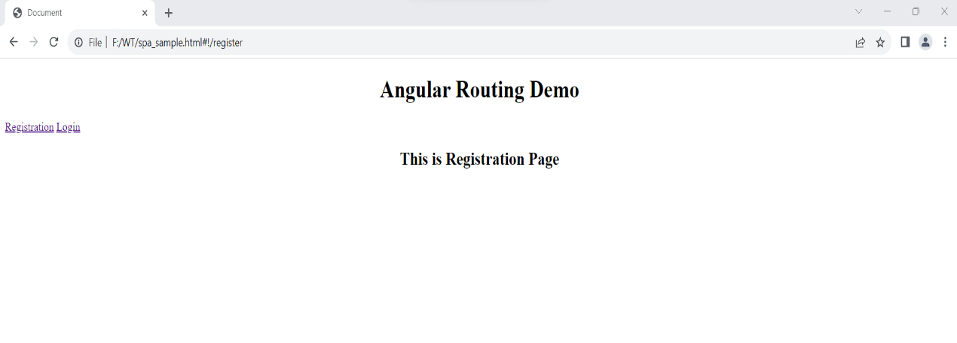

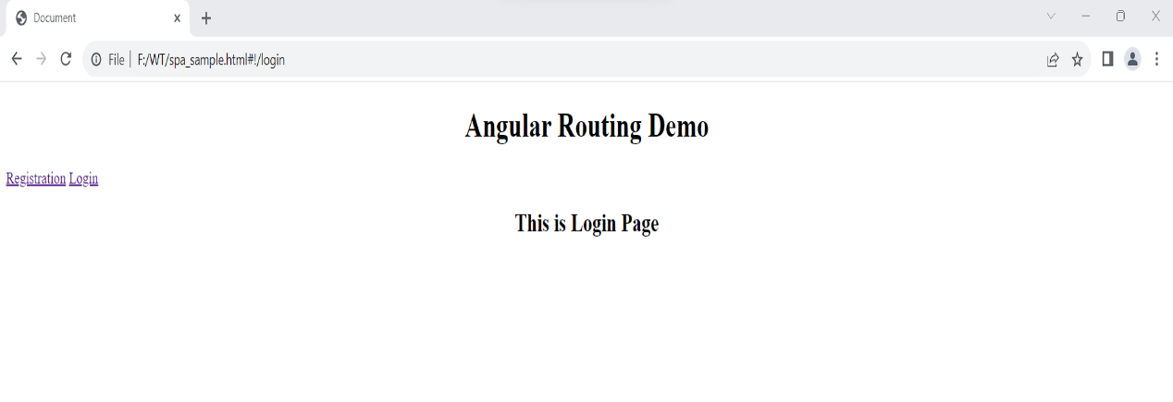

PRACTICAL.NO:16

**Create an application with Login page and Registration Page using Single Page Application (SPA)**

**Code :**

<!DOCTYPE html>

<html lang="en">

<head>

<meta charset="UTF-8">

<meta name="viewport" content="width=device-width, initial-scale=1.0">

<title>Document</title>

<script src="angular.min.js"></script>

<script src="angular.route.js"></script>

</head>

<body ng-app="ngRoutingDemo">

<h1>

<center>Angular Routing Demo</center>

</h1>

<div>

<a href="#!/reg">Registration</a>

<a href="#!/login">Login</a>

</div>

<div ng-view align="center"></div>

<script>

var app = angular.module('ngRoutingDemo', ['ngRoute']);

app.config(function ($routeProvider) {

$routeProvider

.when("/reg", {

templateUrl: "reg.html"

})

.when("/login", {

templateUrl : "login.html"

})

});

</script>

</body>

</html>

Reg.html

<!DOCTYPE html>

<html lang="en">

<head>

<meta charset="UTF-8">

<meta name="viewport" content="width=device-width, initial-scale=1.0">

<title>Document</title>

<style>

@import url('https://fonts.googleapis.com/css?family=PT+Sans');

body {

background: #fff;

font-family: 'PT Sans', sans-serif;

}

h2 {

padding-top: 1.5rem;

}

a {

color: #333;

}

a:hover {

color: #da5767;

text-decoration: none;

}

.card {

border: 0.40rem solid #f8f9fa;

top: 10%;

}

.form-control {

background-color: #f8f9fa;

padding: 20px;

padding: 10px 15px;

margin-bottom: 1.3rem;

}

.form-control:focus {

color: #000000;

background-color: #ffffff;

border: 3px solid #da5767;

outline: 0;

box-shadow: none;

}

.btn {

padding: 0.6rem 1.2rem;

background: #da5767;

border: 2px solid #da5767;

}

.btn-primary:hover {

background-color: #df8c96;

border-color: #df8c96;

transition: .3s;

}

</style>

</head>

<body>

<div class="container">

<div class="row justify-content-center">

<div class="col-md-5">

<div class="card">

<h2 class="card-title text-center">Register <a href="http://opensnippets.com">open snippets</a></h2>

<div class="card-body py-md-4">

<form _lpchecked="1">

<div class="form-group">

<input type="text" class="form-control" id="name" placeholder="Name">

</div>

<div class="form-group">

<input type="email" class="form-control" id="email" placeholder="Email">

</div>

<div class="form-group">

<input type="password" class="form-control" id="password" placeholder="Password">

</div>

<div class="form-group">

<input type="password" class="form-control" id="confirm-password"

placeholder="confirm-password">

</div>

<div class="d-flex flex-row align-items-center justify-content-between">

<a href="#">Login</a>

<button class="btn btn-primary">Create Account</button>

</div>

</form>

</div>

</div>

</div>

</div>

</div>

</body>

</html>

Login.html

<!DOCTYPE html>

<html lang="en">

<head>

<meta charset="UTF-8">

<meta name="viewport" content="width=device-width, initial-scale=1.0">

<title>Document</title>

<style>

*{

padding: 0;

margin: 0;

box-sizing: border-box;

}

main {

width: 600px;

min-height: 400px;

display: flex;

flex-direction: column;

padding: 50px 40px;

border: 1px solid black;

gap: 20px;

background-color: #2D9596;

box-shadow: 5px 5px 2px 1px rgba(0, 0, 255, .2);

}

main div {

display: flex;

flex-direction: column;

gap: 5px;

}

input {

padding: 10px 20px;

box-shadow: 5px 5px 2px 1px rgba(0, 0, 255, .2);

}

span {

font-weight: bold;

text-transform: uppercase;

}

button {

padding: 10px 20px;

background-color: #ECF4D6;

border: none;

outline: none;

transition: 1s ease-in-out;

}

button:hover {

transform: scale(1.1);

}

</style>

</head>

<body>

<main>

<div>

<span>Login</span>

<input type="text" placeholder="Enter Your username">

</div>

<div>

<span>Password</span>

<input type="password" placeholder="Enter Your Password">

</div>

<div>

<button>Login</button>

</div>

</main>

</body>

</html>

**Output :**

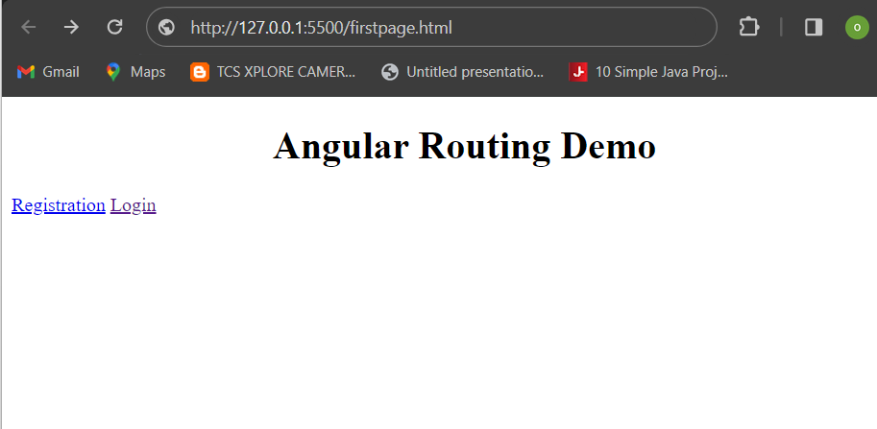

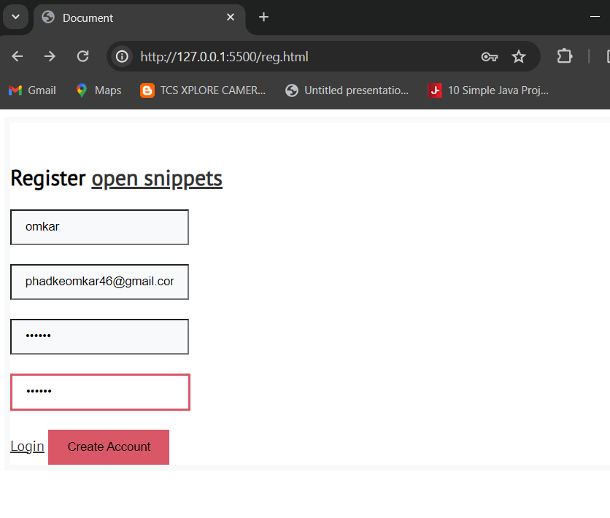

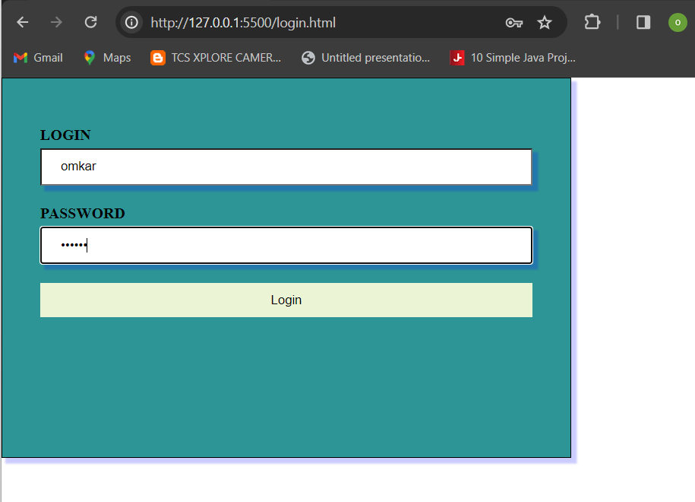

**-----END-----**